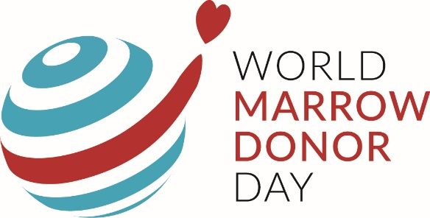

Did you know that World Marrow Donor Day (WMDD) is coming up on Saturday 19th September?
What is WMDD?
- Special day celebrated annually to thank all blood stem cell donors worldwide. A big thank you to you if you are a registered donor on behalf of all the families who have needed or will need a donor.
- It is also a day to raise awareness about the importance of registering as a stem cell donor.
Why be a blood stem cell donor?
- There is a long list of blood disorders that can be cured by a blood stem cell transplant
- Only in 30% of the patients a suitable donor is found within the family
- 70% therefore rely on the worldwide register of unrelated donors
- You could be the one match for them and give them a second chance of life
- You never know, someone close to you may need a donor in the future, at short notice
- A simple way to make a difference in society and save lives.
Patient Profile - Veer
- Veer is only four. He has a rare genetic disorder that impacts his bone marrow
- He doesn’t have long to find a matching stem cell donor
- Matching is heavily influenced by ethnicity. The chances for many people to find a perfect match are 70%, but Veer’s chances are ONLY 20% because there are few Asians/BAME people on the registers.
You can make a difference!!
- With ONLY 2% of the UK population registered as stem cell donors, we have the opportunity to change the statistics and give everyone a better and equal chance of finding a match.
- Registering as a donor is easy – just a cheek swab in the comfort of your home
- If you are a match, donating is also relatively easy. In most cases it is similar to giving blood.
We hope that by celebrating WMDD and sharing Veer’s story, we can all make a difference today. To find out more about becoming a potential donor (a.k.a lifesaver), please take a look at this video.
To register as a donor today, please head to www.dkms.org.uk/en/veer
For more information on Veer’s story, and his parent’s campaign, please head to www.helpveernow.org, or find them on social media @helpveernow.

